Análisis de complejidad:

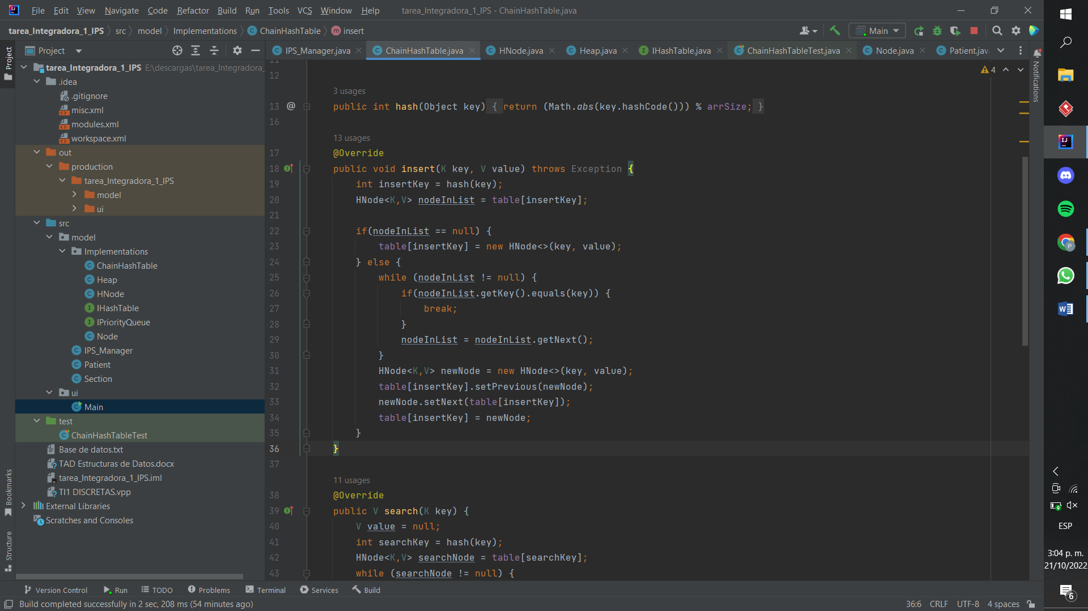

|  |  |
| --- | --- |
| 1 | 1 |
| 2 | 1 |
| 3 | C3 |
| 4 | 1 |
| 5 | 1 |
| 6 | 1 |
| 7 | N+1 |
| 8 | N |
| 9 | 1 |
| 10 | C10 |
| 11 | N |
| 12 | C12 |
| 13 | 1 |
| 14 | 1 |
| 15 | 1 |
| 16 | 1 |
| 17 |  |
| 18 |  |

1+1+1+1+1+N+1+N+1+N+1+1+1+1

11+2N

O(N)

$$11+2N≤C(N)$$

$$\frac{11}{N}+\frac{2N}{N}≤\frac{C*(N)}{N}$$

$$\frac{11}{N}+2≤C$$

$$∀\frac{11}{N}+2≤C$$

N=1

C=13

O(N)

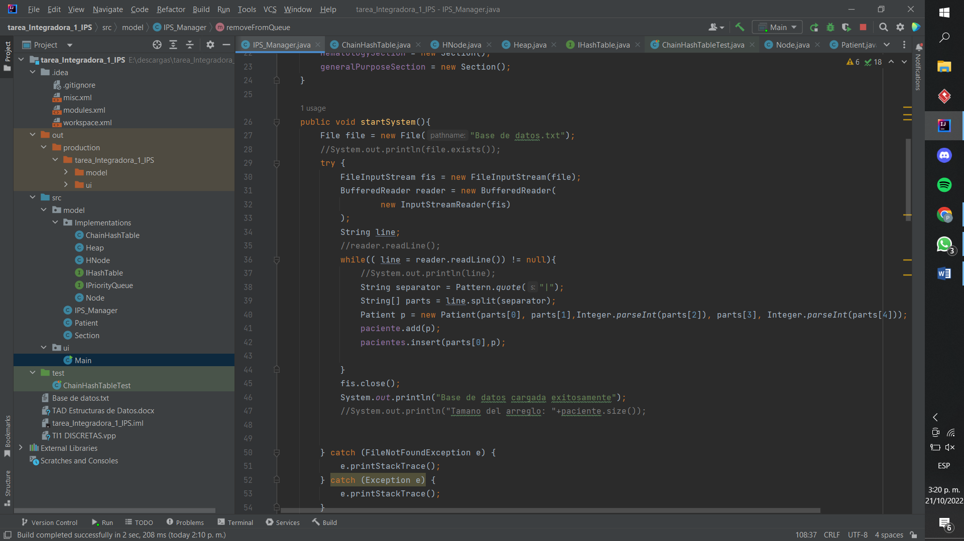

|  |  |
| --- | --- |
| 1 | 1 |
| 2 | C2 |
| 3 | C3 |
| 4 | 1 |
| 5 | 1 |
| 6 | 1 |
| 7 | C7 |
| 8 | 1 |
| 9 | C8 |
| 10 | N+1 |
| 11 | C11 |
| 12 | N |
| 13 | N |
| 14 | N |
| 15 | N |
| 16 | N |
| 17 | C17 |
| 18 | C18 |
| 19 | 1 |
| 20 | 1 |
| 21 | C21 |
| 22 | C22 |
| 23 | C23 |
| 24 | C24 |
| 25 | C25 |
| 26 | C26 |
| 27 | C27 |
| 28 | C28 |
| 29 | C29 |

1+1+1+1+1+N+1+N+N+N+N+N+1+1

8+6N

O(N)

$$7+6N≤C(N)$$

$$\frac{7}{N}+\frac{6N}{N}≤\frac{C(N)}{N}$$

$$\frac{7}{N}+6≤C$$

N=7

C=8

O(N)